1)
a)
.MODEL MOSN NMOS LEVEL=2 LD=0.15U TOX=200.0E-10
+ NSUB=5.36726E+15 VTO=0.743469 KP=8.00059E-05 GAMMA=0.543
+ PHI=0.6 U0=655.881 UEXP=0.157282 UCRIT=31443.8
+ DELTA=2.39824 VMAX=55260.9 XJ=0.25U LAMBDA=0.0367072
+ NFS=1E+12 NEFF=1.001 NSS=1E+11 TPG=1.0 RSH=70.00
+ CGDO=4.3E-10 CGSO=4.3E-10 CJ=0.0003 MJ=0.6585
+ CJSW=8.0E-10 MJSW=0.2402 PB=0.58

*eleman bağlantıları

VDD 3 0 DC 3.1
R1 3 2 100K
VIN 1 0 pulse (0 3.1 0 1n 1n 5n 10n)

M1 2 1 0 0 MOSN W=1.8u L=1.2u NRS=0.333 NRD=0.333
+ AD=6.5p PD=9.0u AS=6.5p PS=9.0u
C1 2 0 1f
.control
dc VIN 0 3.1 0.01
plot V(2) vs V(1)
.endc
.end

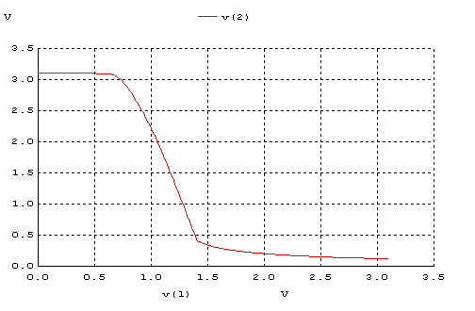

b)
.MODEL MOSN NMOS LEVEL=2 LD=0.15U TOX=200.0E-10
+ NSUB=5.36726E+15 VTO=0.743469 KP=8.00059E-05 GAMMA=0.543
+ PHI=0.6 U0=655.881 UEXP=0.157282 UCRIT=31443.8
+ DELTA=2.39824 VMAX=55260.9 XJ=0.25U LAMBDA=0.0367072
+ NFS=1E+12 NEFF=1.001 NSS=1E+11 TPG=1.0 RSH=70.00
+ CGDO=4.3E-10 CGSO=4.3E-10 CJ=0.0003 MJ=0.6585
+ CJSW=8.0E-10 MJSW=0.2402 PB=0.58

.MODEL MOSP PMOS LEVEL=2 LD=0.15U TOX=200.0E-10
+ NSUB=4.3318E+15 VTO=-0.738861 KP=2.70E-05 GAMMA=0.58
+ PHI=0.6 U0=261.977 UEXP=0.323932 UCRIT=65719.8
+ DELTA=1.79192 VMAX=25694 XJ=0.25U LAMBDA=0.0612279
+ NFS=1E+12 NEFF=1.001 NSS=1E+11 TPG=-1.0 RSH=120.6
+ CGDO=4.3E-10 CGSO=4.3E-10 CJ=0.0005 MJ=0.5052
+ CJSW=1.349E-10 MJSW=0.2417 PB=0.64

*eleman bağlantıları

VDD 3 0 DC 3.1
VIN 1 0 pulse (0 3.1 0 1n 1n 5n 10n)

M1 2 0 3 3 MOSP W=1.8u L=1.2u NRS=0.333 NRD=0.333
+ AD=6.5p PD=9.0u AS=6.5p PS=9.0u

M2 2 1 0 0 MOSN W=1.8u L=1.2u NRS=0.333 NRD=0.333
+ AD=6.5p PD=9.0u AS=6.5p PS=9.0u
C1 2 0 1f
.control
dc VIN 0 3.1 0.01
plot V(2) vs V(1)
.endc
.end

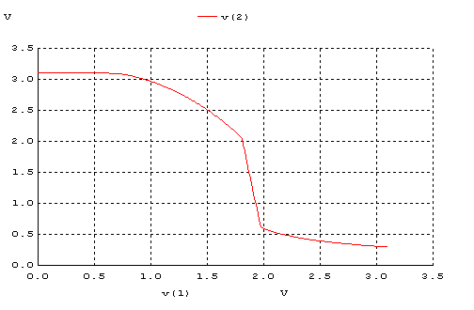

c)
.MODEL MOSP PMOS LEVEL=2 LD=0.15U TOX=200.0E-10
+ NSUB=4.3318E+15 VTO=-0.738861 KP=2.70E-05 GAMMA=0.58
+ PHI=0.6 U0=261.977 UEXP=0.323932 UCRIT=65719.8
+ DELTA=1.79192 VMAX=25694 XJ=0.25U LAMBDA=0.0612279
+ NFS=1E+12 NEFF=1.001 NSS=1E+11 TPG=-1.0 RSH=120.6
+ CGDO=4.3E-10 CGSO=4.3E-10 CJ=0.0005 MJ=0.5052
+ CJSW=1.349E-10 MJSW=0.2417 PB=0.64

*eleman bağlantıları

VDD 3 0 DC 3.1
VIN 1 0 pulse (0 3.1 0 1n 1n 5n 10n)

M1 2 1 3 3 MOSP W=1.8u L=1.2u NRS=0.333 NRD=0.333
+ AD=6.5p PD=9.0u AS=6.5p PS=9.0u
C1 2 0 1f
R1 2 0 100K
.control
dc VIN 0 3.1 0.01
plot V(2) vs V(1)
.endc
.end
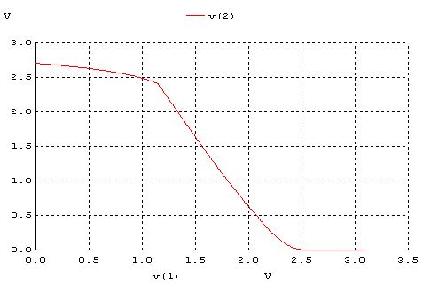
d)
.MODEL MOSN NMOS LEVEL=2 LD=0.15U TOX=200.0E-10
+ NSUB=5.36726E+15 VTO=0.743469 KP=8.00059E-05 GAMMA=0.543
+ PHI=0.6 U0=655.881 UEXP=0.157282 UCRIT=31443.8
+ DELTA=2.39824 VMAX=55260.9 XJ=0.25U LAMBDA=0.0367072
+ NFS=1E+12 NEFF=1.001 NSS=1E+11 TPG=1.0 RSH=70.00
+ CGDO=4.3E-10 CGSO=4.3E-10 CJ=0.0003 MJ=0.6585
+ CJSW=8.0E-10 MJSW=0.2402 PB=0.58

.MODEL MOSP PMOS LEVEL=2 LD=0.15U TOX=200.0E-10
+ NSUB=4.3318E+15 VTO=-0.738861 KP=2.70E-05 GAMMA=0.58
+ PHI=0.6 U0=261.977 UEXP=0.323932 UCRIT=65719.8
+ DELTA=1.79192 VMAX=25694 XJ=0.25U LAMBDA=0.0612279
+ NFS=1E+12 NEFF=1.001 NSS=1E+11 TPG=-1.0 RSH=120.6
+ CGDO=4.3E-10 CGSO=4.3E-10 CJ=0.0005 MJ=0.5052
+ CJSW=1.349E-10 MJSW=0.2417 PB=0.64

*eleman bağlantıları

VDD 3 0 DC 3.1
VIN 1 0 pulse (0 3.1 0 1n 1n 5n 10n)

M1 2 1 3 3 MOSP W=1.8u L=1.2u NRS=0.333 NRD=0.333
+ AD=6.5p PD=9.0u AS=6.5p PS=9.0u

M2 2 1 0 0 MOSN W=1.8u L=1.2u NRS=0.333 NRD=0.333
+ AD=6.5p PD=9.0u AS=6.5p PS=9.0u
C1 2 0 1f
.control
dc VIN 0 3.1 0.01
plot V(2) vs V(1)
.endc
.end
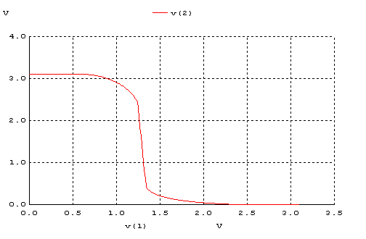
 | VOH | VOL | VIH | VIL | VM | NMH | NML
(a) | 3,1 V | 0,3 V | 1,3 V | 0,6 V | 1,26 V | 1,8 V | 0,3 V
(b) | 3,1 V | 0,5 V | 2,0 V | 1,5 V | 1,7 V | 1,1 V | 1 V
(c) | 2,75 V | 0 V | 2,3 V | 1,3 V | 1,5 V | 0,45 V | 1,3 V
(d) | 3,1 V | 0,15 V | 1,3 V | 1,15 V | 1,38 V | 1,8 V | 1 V
2)
a)
.MODEL MOSN NMOS LEVEL=2 LD=0.15U TOX=200.0E-10
+ NSUB=5.36726E+15 VTO=0.743469 KP=8.00059E-05 GAMMA=0.543
+ PHI=0.6 U0=655.881 UEXP=0.157282 UCRIT=31443.8
+ DELTA=2.39824 VMAX=55260.9 XJ=0.25U LAMBDA=0.0367072
+ NFS=1E+12 NEFF=1.001 NSS=1E+11 TPG=1.0 RSH=70.00
+ CGDO=4.3E-10 CGSO=4.3E-10 CJ=0.0003 MJ=0.6585
+ CJSW=8.0E-10 MJSW=0.2402 PB=0.58

*eleman bağlantıları

VDD 3 0 DC 3.1
R1 3 2 100K
VIN 1 0 pulse (0 3.1 0 1n 1n 5n 10n)

M1 2 1 0 0 MOSN W=1.8u L=1.2u NRS=0.333 NRD=0.333
+ AD=6.5p PD=9.0u AS=6.5p PS=9.0u
C1 2 0 1f
.control
tran 1p 20ns
plot V(2) V(1)
.endc
.end

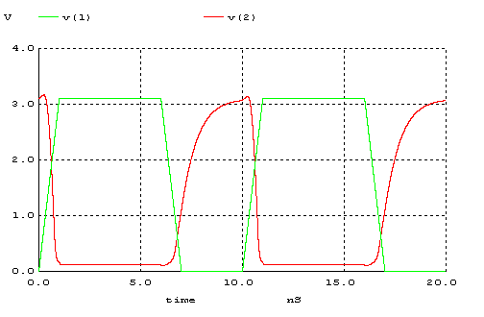
b)
.MODEL MOSN NMOS LEVEL=2 LD=0.15U TOX=200.0E-10
+ NSUB=5.36726E+15 VTO=0.743469 KP=8.00059E-05 GAMMA=0.543
+ PHI=0.6 U0=655.881 UEXP=0.157282 UCRIT=31443.8
+ DELTA=2.39824 VMAX=55260.9 XJ=0.25U LAMBDA=0.0367072
+ NFS=1E+12 NEFF=1.001 NSS=1E+11 TPG=1.0 RSH=70.00
+ CGDO=4.3E-10 CGSO=4.3E-10 CJ=0.0003 MJ=0.6585
+ CJSW=8.0E-10 MJSW=0.2402 PB=0.58

.MODEL MOSP PMOS LEVEL=2 LD=0.15U TOX=200.0E-10
+ NSUB=4.3318E+15 VTO=-0.738861 KP=2.70E-05 GAMMA=0.58
+ PHI=0.6 U0=261.977 UEXP=0.323932 UCRIT=65719.8
+ DELTA=1.79192 VMAX=25694 XJ=0.25U LAMBDA=0.0612279
+ NFS=1E+12 NEFF=1.001 NSS=1E+11 TPG=-1.0 RSH=120.6
+ CGDO=4.3E-10 CGSO=4.3E-10 CJ=0.0005 MJ=0.5052
+ CJSW=1.349E-10 MJSW=0.2417 PB=0.64

VDD 3 0 DC 3.1
VIN 1 0 pulse (0 3.1 0 1n 1n 5n 10n)

M1 2 0 3 3 MOSP W=1.8u L=1.2u NRS=0.333 NRD=0.333
+ AD=6.5p PD=9.0u AS=6.5p PS=9.0u

M2 2 1 0 0 MOSN W=1.8u L=1.2u NRS=0.333 NRD=0.333
+ AD=6.5p PD=9.0u AS=6.5p PS=9.0u
C1 2 0 1f
.control
tran 1p 20ns
plot V(2) V(1)
.endc
.end

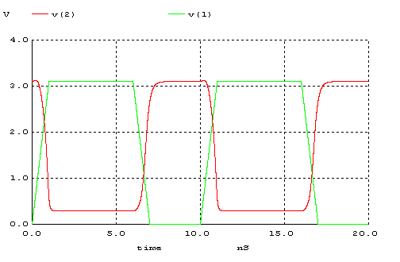

c)
.MODEL MOSP PMOS LEVEL=2 LD=0.15U TOX=200.0E-10
+ NSUB=4.3318E+15 VTO=-0.738861 KP=2.70E-05 GAMMA=0.58
+ PHI=0.6 U0=261.977 UEXP=0.323932 UCRIT=65719.8
+ DELTA=1.79192 VMAX=25694 XJ=0.25U LAMBDA=0.0612279
+ NFS=1E+12 NEFF=1.001 NSS=1E+11 TPG=-1.0 RSH=120.6
+ CGDO=4.3E-10 CGSO=4.3E-10 CJ=0.0005 MJ=0.5052
+ CJSW=1.349E-10 MJSW=0.2417 PB=0.64

*eleman bağlantıları

VDD 3 0 DC 3.1
VIN 1 0 pulse (0 3.1 0 1n 1n 5n 10n)

M1 2 1 3 3 MOSP W=1.8u L=1.2u NRS=0.333 NRD=0.333
+ AD=6.5p PD=9.0u AS=6.5p PS=9.0u
C1 2 0 1f
R1 2 0 100K
.control
tran 1p 20ns
plot V(2) V(1)
.endc
.end
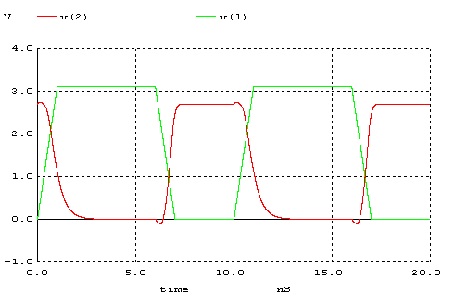
d)
.MODEL MOSN NMOS LEVEL=2 LD=0.15U TOX=200.0E-10
+ NSUB=5.36726E+15 VTO=0.743469 KP=8.00059E-05 GAMMA=0.543
+ PHI=0.6 U0=655.881 UEXP=0.157282 UCRIT=31443.8
+ DELTA=2.39824 VMAX=55260.9 XJ=0.25U LAMBDA=0.0367072
+ NFS=1E+12 NEFF=1.001 NSS=1E+11 TPG=1.0 RSH=70.00
+ CGDO=4.3E-10 CGSO=4.3E-10 CJ=0.0003 MJ=0.6585
+ CJSW=8.0E-10 MJSW=0.2402 PB=0.58

.MODEL MOSP PMOS LEVEL=2 LD=0.15U TOX=200.0E-10
+ NSUB=4.3318E+15 VTO=-0.738861 KP=2.70E-05 GAMMA=0.58
+ PHI=0.6 U0=261.977 UEXP=0.323932 UCRIT=65719.8
+ DELTA=1.79192 VMAX=25694 XJ=0.25U LAMBDA=0.0612279
+ NFS=1E+12 NEFF=1.001 NSS=1E+11 TPG=-1.0 RSH=120.6
+ CGDO=4.3E-10 CGSO=4.3E-10 CJ=0.0005 MJ=0.5052
+ CJSW=1.349E-10 MJSW=0.2417 PB=0.64

*eleman bağlantıları

VDD 3 0 DC 3.1
VIN 1 0 pulse (0 3.1 0 1n 1n 5n 10n)

M1 2 1 3 3 MOSP W=1.8u L=1.2u NRS=0.333 NRD=0.333
+ AD=6.5p PD=9.0u AS=6.5p PS=9.0u

M2 2 1 0 0 MOSN W=1.8u L=1.2u NRS=0.333 NRD=0.333
+ AD=6.5p PD=9.0u AS=6.5p PS=9.0u
C1 2 0 1f
.control
tran 1p 20ns
plot V(2) V(1)
.endc
.end

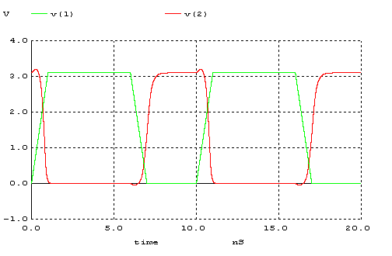
 | tr | tf | tPLH | tPHL | td
(a) | 2 ns | 0,4 ns | 0,8 ns | 0,2 ns | 0,5 ns
(b) | 0,4 ns | 0,4 ns | 0,2 ns | 0,4 ns | 0,3 ns
(c) | 1,5 ns | 3 ns | 0,3 ns | 0,3 ns | 0,3 ns
(d) | 0,4 ns | 0,3 ns | 0,5 ns | 0,3 ns | 0,4 ns

3-)

a) 4 devre içerisinden (b) şıkkındaki devre en iyi sonucu vermektedir. Tersleyici devrelerinde transient bölgenin kısa olmasını yani Noise Margin aralığının geniş olması daha iyidir. Transient bölgesi kısa olması istemediğimiz sonuçların çıkmasını engeller. Ayrıca High ve Low kısımların simetrik olmasını ve burada yüksek kazanç elde etmeyi isteriz.

b) Soruda verilen 4 devre simetrik değildir. Eğer NMOS ve PMOS dirençleri ile R1 dirençlerimiz eşit olsaydı devreler simetrik olurdu.

+)
.MODEL MOSN NMOS LEVEL=2 LD=0.15U TOX=200.0E-10
+ NSUB=5.36726E+15 VTO=0.743469 KP=8.00059E-05 GAMMA=0.543
+ PHI=0.6 U0=655.881 UEXP=0.157282 UCRIT=31443.8
+ DELTA=2.39824 VMAX=55260.9 XJ=0.25U LAMBDA=0.0367072
+ NFS=1E+12 NEFF=1.001 NSS=1E+11 TPG=1.0 RSH=70.00
+ CGDO=4.3E-10 CGSO=4.3E-10 CJ=0.0003 MJ=0.6585
+ CJSW=8.0E-10 MJSW=0.2402 PB=0.58

.MODEL MOSP PMOS LEVEL=2 LD=0.15U TOX=200.0E-10
+ NSUB=4.3318E+15 VTO=-0.738861 KP=2.70E-05 GAMMA=0.58
+ PHI=0.6 U0=261.977 UEXP=0.323932 UCRIT=65719.8
+ DELTA=1.79192 VMAX=25694 XJ=0.25U LAMBDA=0.0612279
+ NFS=1E+12 NEFF=1.001 NSS=1E+11 TPG=-1.0 RSH=120.6
+ CGDO=4.3E-10 CGSO=4.3E-10 CJ=0.0005 MJ=0.5052
+ CJSW=1.349E-10 MJSW=0.2417 PB=0.64

*eleman bağlantıları

VDD 3 0 DC 3.1
VIN 1 0 pulse (0 3.1 0 1n 1n 5n 10n)

M1 2 1 3 3 MOSP W=5.4u L=1.2u NRS=0.111 NRD=0.111
+ AD=16.2p PD=11.4u AS=16.2p PS=11.4u

M2 2 1 0 0 MOSN W=1.8u L=1.2u NRS=0.333 NRD=0.333
+ AD=6.5p PD=9.0u AS=6.5p PS=9.0u
.control
dc VIN 0 3.1 0.01
plot V(2) vs V(1)
.endc
.end

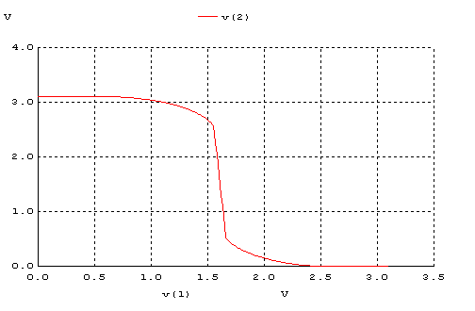
VOH | VOL | VIH | VIL | VM | NMH | NML
3,1 V | 0 V | 1,4 V | 1,7 V | 1,6 V | 1,7 V | 1,7 V

.MODEL MOSN NMOS LEVEL=2 LD=0.15U TOX=200.0E-10
+ NSUB=5.36726E+15 VTO=0.743469 KP=8.00059E-05 GAMMA=0.543
+ PHI=0.6 U0=655.881 UEXP=0.157282 UCRIT=31443.8
+ DELTA=2.39824 VMAX=55260.9 XJ=0.25U LAMBDA=0.0367072
+ NFS=1E+12 NEFF=1.001 NSS=1E+11 TPG=1.0 RSH=70.00
+ CGDO=4.3E-10 CGSO=4.3E-10 CJ=0.0003 MJ=0.6585
+ CJSW=8.0E-10 MJSW=0.2402 PB=0.58

.MODEL MOSP PMOS LEVEL=2 LD=0.15U TOX=200.0E-10
+ NSUB=4.3318E+15 VTO=-0.738861 KP=2.70E-05 GAMMA=0.58
+ PHI=0.6 U0=261.977 UEXP=0.323932 UCRIT=65719.8
+ DELTA=1.79192 VMAX=25694 XJ=0.25U LAMBDA=0.0612279
+ NFS=1E+12 NEFF=1.001 NSS=1E+11 TPG=-1.0 RSH=120.6
+ CGDO=4.3E-10 CGSO=4.3E-10 CJ=0.0005 MJ=0.5052
+ CJSW=1.349E-10 MJSW=0.2417 PB=0.64

*eleman bağlantıları

VDD 3 0 DC 3.1
VIN 1 0 pulse (0 3.1 0 1n 1n 5n 10n)

M1 2 1 3 3 MOSP W=5.4u L=1.2u NRS=0.111 NRD=0.111
+ AD=16.2p PD=11.4u AS=16.2p PS=11.4u

M2 2 1 0 0 MOSN W=1.8u L=1.2u NRS=0.333 NRD=0.333
+ AD=6.5p PD=9.0u AS=6.5p PS=9.0u
.control
tran 1p 20ns
plot V(2) V(1)
.endc
.end

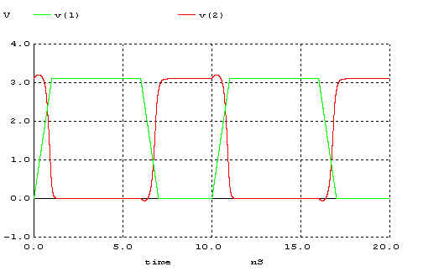

1 .sorunun (d) şıkkındaki devre üzerinde PMOS direncinde değişiklik yaptık. PMOS’un W/L oranını 3 katına çıkardık ve PMOS’un direnci 3 kat azaldı. Bu nedenle VM değeri grafikte yukarıya doğru çıkmıştır.Yani 1 soruda 1,38 V olan VM değeri PMOS direncini değiştirince 1,6 V değerine çıkmıştır.

